

SEMESTER ONE 2020
Light & Sound Test:
ANSWER BOOKLET

NAME: ANSWERS

I CAN STATEMENTS | QUESTIONS
MUST  Explains that energy can be transferred using wave and particle models. | 2, 4, 5, 6, 7, 8, 9, 10, 11, 13, 14, 15, 17, 18, 20, 21a,b, 23
SHOULD  Explains that energy can be transferred using wave and particle models and provides appropriate example. | 1,12,15,16,17,18,19,21c
COULD  Explains how energy can be transferred through different mediums using wave and particle models, relating each method to appropriate examples. | 3, 18,19, 23

Multiple Choice Short Answer Extended Answer Total

/5

/13

/29

/47

SECTION ONE: Multiple choice answers
Cross (X) through the correct answer.

1 | a | b | XXXX | d
2 | a | b | c | XXXX
3 | XXXX | b | c | d
4 | XXXX | b | c | d
5 | a | XXXX | c | d
6 | a | XXXX | c | d
7 | a | b | XXXX | d
8 | a | XXXX | c | d
9 | a | b | c | XXXX
10 | XXXX | b | c | d
11 | XXXX | b | c | d
12 | a | b | XXXX | d
13 | a | XXXX | c | d

SECTION TWO: Short Answer (29 marks)

Answer the questions in the spaces provided.

14. a) “In Space, no one can hear you scream” is a quote from the movie “Alien”. Explain why this quote is true. (2 marks)
- Sound is a mechanical wave
- Needs a medium to travel
- Space has no medium
(any 2)
b) Light is able to travel through space. Explain why (2 marks)
- Light is an electromagnetic wave
- Light can travel through vacuum
- Doesn’t need a medium
- The wave doesn’t get smaller (electromagnetic waves self-propagating)
(any reasonable 2)
15. Label the diagram below using the terms: amplitude, wavelength, crest and trough (2 marks)
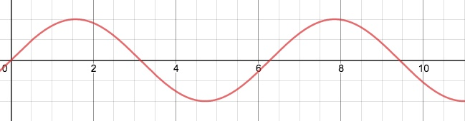

(1/ 2 mark each)

16. The audio frequency oscillator was producing the following sound wave on the cathode ray oscilloscope.

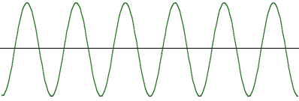
Draw below what the wave will look like if the frequency of the sound were to increase (2 marks)
- Same amplitude
- Squishy graph

17. Two fire trucks with sirens on speed towards and away from an observer as shown below.
a) Which truck produces a higher than normal siren frequency? Explain why do you think so?

Truck 1 ( 1 mark) When the truck moves towards an observer, the sound of its siren seems relatively high pitched ( ½ mark), a high frequency sound will have high pitch ( ½ mark)

( or if the students make a link with the spacing between the waves and answer based on the wavelength you can give mark)

b) With the help of an arrow, show in the diagram above where the wavelength is higher than normal siren frequency? Explain why do you think so? (2marks)

Arrow must be near the waves of Truck 2 ( 1 mark) more space between the waves / waves are further apart/ wavelength is higher (1 mark) compared to truck 1 ( Any reasonable answer)

18. A person who is blind wants to buy a house that has large rooms. They are able to gauge the size of a room by clicking. Explain how this is possible by using your knowledge of how sound travels. (3 marks)
- Sound can be reflected off objects
- Distance relates to time sound takes to travel
- The longer the sound takes to return, the further away the object is

19. Draw a diagram of a light ray hitting a mirror and obeying the Law of Reflection. Be sure to label the normal, the angle of incidence and angle of reflection. (4 marks)

- Normal at 90 to the mirror
- Angle of incidence and angle of reflection is same
- Angle of incidence and angle of reflection labeled correctly
- Arrows drawn on the rays
(1 mark each)

20. Define the following terms and give an example of an object with this (6 marks)

- Transparent
- Light passes through, can see straight through (1 mark)
- Glass (1 mark for any reasonable example)
- Translucent
- Light partially passes through, can see some (1 mark)
- Plastic, paper (1 mark for any reasonable example)
- Opaque
- Can’t see through, light doesn’t pass (1 mark)
- Basketball (1 mark for any reasonable example)

21. Isaac Newton identified seven colours of the rainbow.

- List the three primary colours for light? (1.5marks)

- Red
- Blue
- Green
- List the three secondary colours of light? (1.5marks)

- Cyan
- Magenta
- Yellow

- Explain why they are called the primary colours of light (1 mark)
- Combine to form other colours of light

SECTION THREE: EXTENDED ANSWER (5 marks)

22. Identify two factors that affect the speed of sound and explain how they change the speed using your knowledge of energy and waves.

Two factors: Temperature and density (1mark each)
The speed of sound increases with temperature (1/2 mark) because at higher temperatures, the particles have more kinetic energy (1/2 mark) and so vibrate more quickly and compress more easily (1/2 mark). The speed of sound increases with the density of the material (1/2 mark) because sound waves are the result of vibrating particles (1/2 mark). The more closely packed the particles, the more easily they can transfer the energy to each other (1/2 mark).

( Any reasonable answer)

